**Week 1**

**Introduction to classification**

**Instructions:** *Carefully read the learning intentions and success criteria, these are the goals for this week. Read the content section, take notes and answer the questions on page 10. Complete the two lab activities by following the instructions and answering the discussion questions afterwards. The ICT activity requires you to complete research on the internet, follow the instructions and if you need there are some additional learning resources at the back of the workbook.*

**Learning Intention:**

This week we are starting a new unit of work, it is based on the classification of living things. This week we are going to do a general introduction to the topic. We will be learning about how scientists classify things, the Linnaeus classification system and how to make dichotomous keys.

**Success Criteria:**

1. Be able to state the reasons and the purpose of using classification.
2. Consider how classification systems have changed over time.
3. Be able to construct classification keys

**Background**

About 1.7 million different types of living things or organisms that live on Earth have been identified and described. It is easier to find products in a supermarket when they are grouped, and in a similar way it’s easier to describe and talk about living things on Earth if they are sorted into groups. Taxonomists classify organisms into groups by sing the characteristics they have in common.

**Content**

**Classification organises our world**

Early scientists did not have photography or computers to record and catalogue images of the curious new plants and animals they discovered. Instead, they needed to rely on hand-drawn pictures and worded descriptions. Classification systems were developed to help scientists communicate with each other despite their different locations and languages.

**Early classification methods**

Early humans first classified plants by learning which plants were edible and which were poisonous. A new plant or animal discovered by humans was (and still is) studied and put into a group. Some plants were found to help sick people and others poisonous. Some animals could produce food (e.g. milk and eggs). Each generation of scientists worked to improve how these groups were classified.

**Common names or scientific names**

Scientists try to communicate with each other regularly to help with their research. Before the existence of photographs or computers, scientists would have to draw creatures, for example birds, by hand and describe them in as much detail as they could. This was difficult, as the photographs of the American magpie and the Australian Magpie show. Both birds look so similar they have been given the same common name, ‘magpie’. However, their scientific names are different. The name *Cracticus tibicen* for the Australian magpie means the same to scientists in every country around the world.

**The Linnaen classification system**

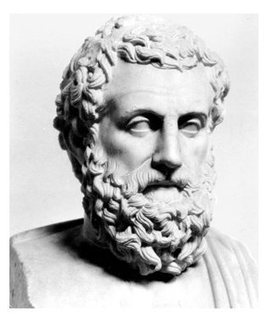The Greek philosopher Aristole (384 – 322 BC) was the first scientist to start using systems to describe plants and animals. By the 17th century the early classification systems used a hierarchy of names, starting with large general groups (e.g. plants, animals) and making subsequent groups smaller and smaller depending on their characteristics. Each organism ended up with a long Latin name that described the characteristics of each level of the hierarchy. Carl Linnaeus (1707 – 1778) tried these classification systems but found their descriptions to be too long. He decided a simpler system was needed. He changed the descriptions to single words and reduced the number of classification groups to seven.

**Finding new species**

Small groups of scientists are trying to find undiscovered plants in Brazilian rainforests before they are destroyed by logging and farming. Often the scientists are supported by large pharmaceutical companies from other countries. Why would companies on the other side of the world be interested in the rainforest? One reason is that we may one day need these medications we currently use come from organisms. Many medications we currently use organisms. The antibiotic penicillin was discovered from a type of mould; aspirin comes from a substance in the bark of a willow tree. The next painkiller could come from a small fungus in the rainforest or from an insect that relies on the fungus for food.

**Giving organisms a precise name**

When trying to find your house on Google Earth, you first find Australia, then the state you live in. Each time you narrow your search closer to your town, your suburb, your street until you finally find your house. The Linnaean dichotomous key for all living things works in a similar way. It starts with large groups called Kingdoms, then it divides into smaller groups called phyla. Each phylum has several classes. The classes have orders, and so on. There are seven different levels to get to the final name of each organism. They are Kingdom, phylum, class, order, family, genus, species.

Tip to remember the Linnaean system: King Phillip Crawled Over Four Gooey Snails

**Linnaeus’s double-name system**

Have you eaten a *Musa sapientum* lately or have they been too expensive to buy? And did you pat your *Canis familiaris* this morning? These are the kinds of double names given to every living thing using the Linnaean classification system.

Our homes can easily be found by using only the two smallest groups in an address (the street and suburb). The information about the bigger groups, like earth and the country, is not really necessary. In much the same way, an organism can also be named from the two last groups on the Linnaean dichotomous key, the genus and the species.



In the double-name or (binomial) system, the genus group name always stars with a capital letter. The second word is the species name and it does not have a capital letter. The double name is always written using italics *(Sloping letter).*

A **species** is a group of organisms that look similar to each other. When they breed in natural conditions, their offspring are fertile (in other words, they can also breed). Domestic cats belong to one species because they can breed together and have kittens.

**The changing face of science**

After 250 years, scientists are still testing and modifying the Linnaean classification system. The development of microscopes led to the discovery of single celled organisms (bacteria). This led to the number of kingdoms increasing from three (plants, animals and minerals) to the current five (plantae, Animalia, Fungi, Protista and Monera). In the 1970’s, a group of organisms previously thought of as bacteria was discovered to be something else: single-celled organism that could live in extreme conditions, such as very salty or hot water.

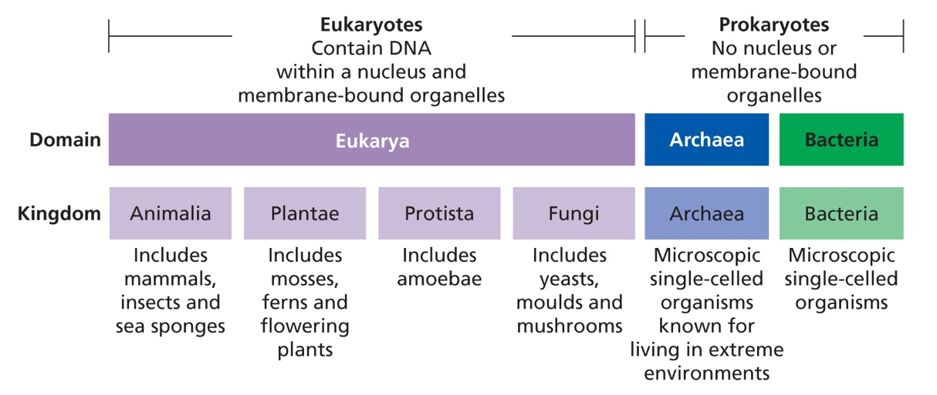The genetic material (DNA) of these organisms was different from that of bacteria. This led to the suggestion that a sixth kingdom, Archaea, was needed. Scientists are currently testing this idea and competing it with a whole new system that comes before kingdoms.

The ‘three domain system’ was first suggested in the 90’s, this system suggests one super domain, Eukaryota, for the plants, animals, protists and fungi. The single-celled organism in kingdom monera would then be split into two domains according to their genetic material.

**Making Classification Keys**

Classification is the process of putting things into groups. It is a skill needed in many areas of life, not only science.

Next time you walk around a supermarket, think about the way products are grouped. Biscuits are all in the same aisle, with savoury biscuits separated from sweet and chocolate biscuits. Canned items are usually together, but canned fruit is separated from baked beans and soups.

Music you download onto your iPod is classified in a variety of ways. This allows you to find the music by searching via artist, album, composer or genre (such as rock, pop and dance).

In a library, the fiction and non-fiction books are in different areas. The non-fiction books are separated into smaller groups defining their subjects, were as fiction books are divided up into their alphabetical order based on the authors names.

**Introducing Keys**

Biologists classify living things. Scientists who specialise in group and naming living things are known as **taxonomists**, and the science of grouping and naming things is called **taxonomy**. Once the characteristics of organisms have been described this information can be used to develop a key. The key is a tool that can then be used to identify unknown organisms.

The simplest type of key is a **dichotomous key**. The word dichotomous means cut in two. A dichotomous key is a series of choices that leads to the identification of an object. At each stage of using a dichotomous key you are given two choices. Each choice leads to another two choices and so on, until there are no choices left to pick and the objects identified.

Keys work best if the features used to make up the choices are easiest to observe, with everyone knowing exactly what they mean. Take height as an example. A person’s height is easy to observe, but words such as tall or short can be interpreted in different ways. You would probably describe someone taller than you as ‘tall’. That same person might describe you as ‘shot’ Tallness is therefore not a good feature for a key. A description such as ‘greater than 1.5 metres height are more reliable.

Two ways of writing keys are as flow charts or tables. The items shown from a pencil case demonstrate the two different ways keys can be displayed.

**Strong Keys**

Some features or characteristics are better to use in a key than others. Size, colour and shape can change as an organism grows and develop or may vary within the same kind of organism. Structural features make a much stronger key that can be used at any time, regardless of age of the organism. It is easy to construct a strong key for something like buttons because they do not change. People like other living things do change with time, and if a key is to be used both now and then and at some point, in the future, then it has to use features that will not change.

**Questions**

1. Why did Carl Linnaeus simplify the classification system used by previous scientists?
2. Give two reasons scientists still classify organisms today?
3. Why would it be difficult to classify frogs and tadpoles using the early methods of classification?
4. What are the seven groups that living things are divided into? Write them in order from largest to smallest level of organisation.
5. How do you know if two organisms are the same species?
6. Select three species of animal. For each animal:
7. describe its appearance
8. Give it common and scientific names
9. How has an understanding of genetic material (DNA) changed classification?

**Lab 1**

**Your pencil case**

**Instructions:** *How could all the things in your pencil case be classified? Follow the steps below and create different groups for the items in your pencil case. Complete the discussion questions once you have done the groupings.*

Do this:

1. Tip the contents of your pencil case out onto a table.
2. Sort the contents into groups and give names to each group.
3. List the items included in each group under the group name.
4. Re-sort the contents into different groups, and gains list the items included in each group.

**Discussion Questions**:

1. Describe how you decided what to include in the groups.
2. Explain which of the groupings was most useful.

**Lab 2**

**Constructing Keys**

**Instructions:** *Answer the questions below to construct classification keys. Draw your keys in a workbook, if you can you can use Microsoft word to create your tables.*

**Question 1.**

Figure 1 shows nine shapes.

1. Classify the objects into three groups on the basis of their surface being smooth, wobbly or spiky.
2. Classify the objects on the basis of their shape being square, circular or rectangle.
3. What is the third basis of classification you could use? Classify the objects using this basis?
4. Is any one of these systems of classification better than the other two?

**Question 2.**

Write a key for the objects in Figure 1. Use the features of shape and pattern only.

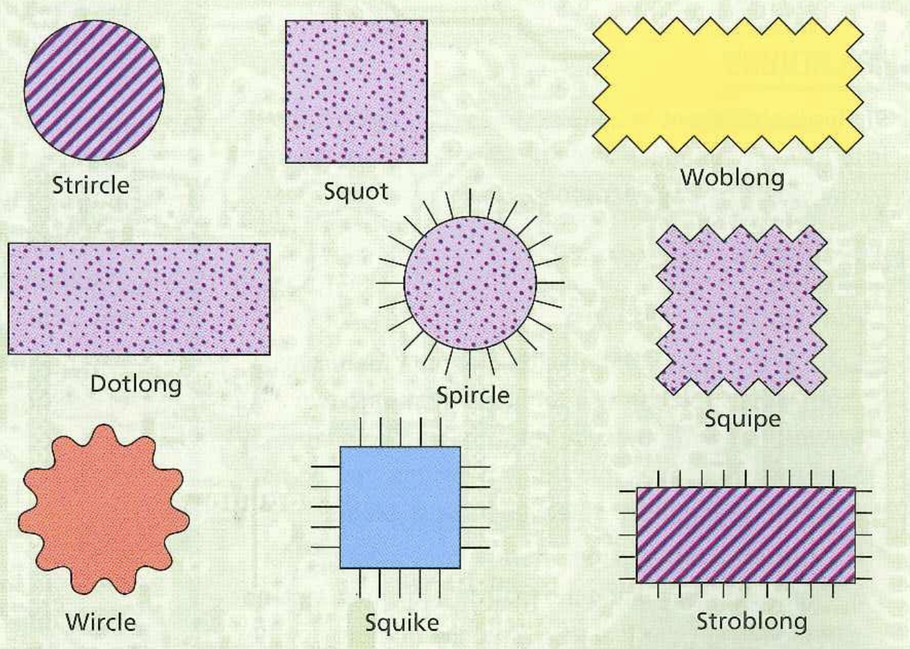

*Figure 1.*

**Lab 2**

**Cont.**

**Question 3.**

Figure 2 shows eight different types of bolts.

1. Classify the bolts as having a round head or not having a round head by writing the letter for each bolt in a suitable table.
2. Classify the bolts as having a long thread or a short thread.
3. Classify all those bolts having a long thread as having a slot in the head or not having a slot in the head.

**Question 4.**

Write a key to the objects in figure 2. You can name them if you like, or just use the letters in the diagram.

**ICT Activity**

**Task 1.**

**Instructions:** *Complete the task below using your own internet research.*

**Define the following terms using the internet:**

1. Classification
2. Unicellular
3. Multicellular
4. Class of organisms

**Task 2.**

**Instructions:** *Complete the table below using your own internet research. Find the scientific name and the meaning of that name.*

1. **Research the scientific names for the following organisms**

|  |  |  |
| --- | --- | --- |
| Animal | Scientific Name | Meaning for Scientific Name |
| Koala | *Phascolarctos cinereus* | *Phascolarctos –* leather bag or pouch  *Cinereus* – appearance, ash colour |
| Kangaroo (grey) |  |  |
| Tiger |  |  |
| Red Eyed Tree Frog |  |  |
| Common Bottlenose Dolphin |  |  |
| Clown Fish |  |  |
| Dog |  |  |
| Cat |  |  |
| Human |  |  |
| Fish |  |  |
| Ape |  |  |
| Elephant |  |  |
| Cherry Blossom |  |  |
| Jacaranda Tree |  |  |
| Boab tree |  |  |

**If I wanted to learn more, I could visit these websites:**

<http://www2.linnaeus.uu.se/online/animal/1_1.html>

<https://study.com/academy/lesson/classifying-living-things-lesson-for-kids.html>

**Summary**

* Classification is the process of putting things into groups. It is a skill needed in many areas of life, not only science.
* The Linnaean classification system was created by Carl Linnaeus in the 1800’s
* This system uses a dichotomous key to classify all living things.
* Starting with the largest group called a Kingdom, all living things are further divided into six smaller groups; moving down the Phylum, Class, Order, Family, Genus, Species
* Scientists use a double-name (or binomial) system to give animals a classification.

**Glossary**

**Classification:**

The process of putting things into groups.

**Linnaean Taxonomy:**

System of classification first developed by Carl Linnaeus (1707 – 1774) in which all organisms are grouped into one of five kingdoms.

**Kingdoms:**

The first level of classification/

**Binomial:**

Double-name system created by Linnaeus to name organism; first name is the genus; the second name is the species.

**Genus:**

A group of closely related species.

**Species:**

Group of organisms that look similar to each other, can breed in natural conditions and produce fertile young.

**Taxonomists:**

A scientist who specialises in grouping and naming things.

**Taxonomy:**

The science of grouping and naming things.

**Dichotomous Key:**

A key with two choices at each stage.

**References**

*Pearson Science 7.* (2011). Melbourne, Australia: Pearson

*Nelson iScience. Year 7: for the Australian curriculum*. (2011). Melbourne, Australia: Cengage Learning

Silvester, H. (2015). *Oxford Science 7*. Melbourne, Australia: Oxford

Williamson, K. (2011). *Science Essentials 7.* Melbourne, Victoria: Macmillan Education